MOTOrcycle meeting IPA Slovakia

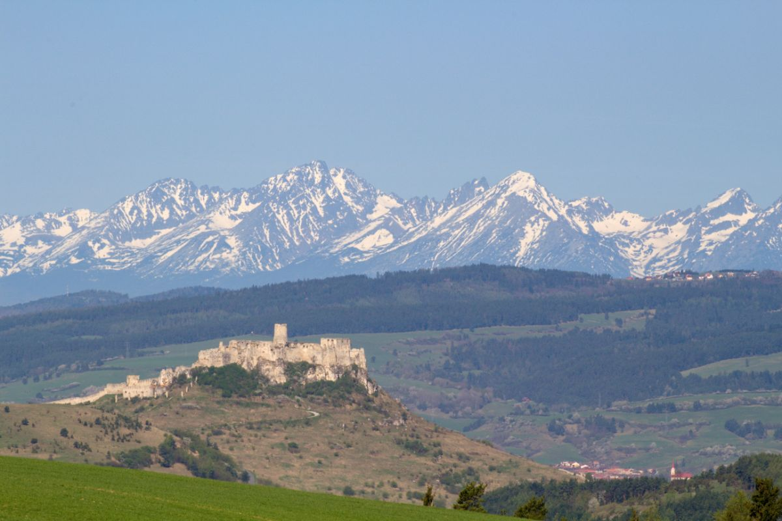

International police association
Slovak section

Zerrenpach Látky, 4. – 7. SEPTEMBER 2025



Program :

1st Day – Thursday 4th September 2025

• Arrival of participants to the hotel Zerrenpach Látky
• 19.00 Welcome cocktail
• 20.00 Dinner

2nd Day – Friday 5th September 2025
• Breakfast at the hotel
• 08:00 leaving for the first motorcycle route
ROUTE:
♣ Zerrenpach Látky, Kokava, Brezno, Čertovica, Važec – Šoldov, Štrbské pleso, lunch Hotel Sorea ...............km 130;
♣ In the afternoon, return back to the hotel Zerrenpach Látky through Liptovská Teplička, Hranovnica, Vernár, Telgárt, Tisovec, Hnúšťa................. 135 km;
• 20.00 Dinner

3rd day – Saturday 6th September 2025

• Breakfast at the hotel
• 08:00 leaving for the motorcycle route
ROUTE:
♣ Zerrenpach Látky, Hriňová, Očová, Banská Bystrica, Donovaly, Ružomberok, Liptovský Hrádok lunch in Koliba Červený kút ...................... 164 km
♣ In the afternoon, return back to the hotel Zerrenpach Látky through Čertovica, Brezno, Čierny Balog, Hriňová, …… 90 km

20:00 Gala evening.

4th Day – Sunday 7th September 2025

• Breakfast at the hotel
• Departure

The price inncludes:

3 days with full board in double bed (triple, four-bed) room, apartments, cottages in 3 ⃰ hotel: 295,00 per person;
- Welcome Cocktail
- Moto assistance
- Wellness avaliable for a fee

Supplement for a single room: 100,00 €

The price does not include:
• Fuel for motorcycle
• Possible reparation costs
• Extra consumption other than those included in the program

NOTE:
Deposit for confirmation of reservation 100,00 € per person, which will be sent by bank transfer and will state the reason: Motorcycle meeting IPA Slovakia names of participants on:
IBAN: SK43 1100 0000 0026 2771 2270

In connection with the reservation, send the completed form and copy of payment confirmation to e-mail: dulin020@gmail.com, richard.kadnar@gmail.com

The last date of registration 30th March 2025

Reservations are accepted until the rooms are occupied

The organizing committee:
• reserves the right to make changes in the program. Important changes will be notified to
participants in due course
• is not responsible for any accidents, injuries, and damages during the route or any violation
of laws committed by participants
• Make sure, that all motorcycles comply with traffic regulations
• For any further informations or reservation, write and call:
Peter +421905447216, Richard +421911324519
dulin020@gmail.com, richard.kadnar@gmail.com

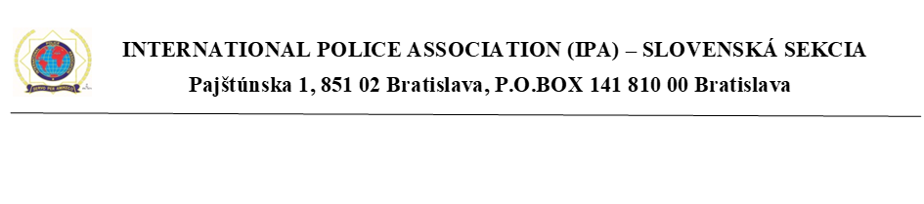
REGISTRATION FORM

Surname  ………………………….. | Name  …………………………….. | Date of birth  …………………………
City & full Andress  …………………………..  ……..……………………  …………………………..  …………………………..  Ipa Member………………..  Non Ipa Member………… | Telephone nr.  ………………….……. | E-Mail  ……………………….
 | Define if :  Driver………….………….  Passenger ………………… | Room  **Double………………...  Single ……………….
Motocycle model  ………………………….. | Registration number  ………………………….. | Size T-Shirt
Motocycle model  ………………………….. | Registration number  ………………………….. | Driver  ……….. | Second person  ………..
**Second person details
Surname  ………………………….. | Name  …………………………….. | Date of birth  …………………………
Down payment

Bank……………………………………………………………………………..
Branch…………………………………………………………………………..
Date……………………………………………………………………………..

;The registrant assumes full responsibility for the above.
The same in aware that the organizers of the event disclaims any civil or criminal liability in relation toinjures, accidents, damage or theft occurred during rhe rally, and moving violations detected by the Highway Police Forees during the travel route or during the stops as provided.
City and Date  ……………………..………. | Signature  ………………………………….…………………

